## **Project (Un)Matter 1-Page GDD**

*A Journey finding friends and “disgraces”, different kind of matters, right to the Truth*

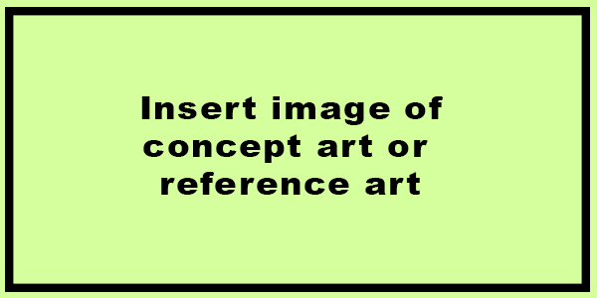

**Genre:** RPG, 3rd person (with controllable camera?)  
**Target Audience:** Teen/Adult

**Controls:** Mouse-Keyboard / Keyboard

**Thematic Setting:** “Modern Fantasy” (with different “ages” across the continents)

**Tech Stack:** Unity 2017 1.1f +, Blender, Gimp, Audacity

**Platform(s):** Steam (3DS?)

**Game Moment:** Turn-based combats (with stats and N moves, that together with characters can ben of 3 different “types”, with a triangle reletionship of effectiveness/immunity)

**Game Summary:**

**Core Player Experience:**

**Central Theme:**

**Design Pillar:**

**Anticipated Remarkability:**

**Anticipated Steam Early Access Launch date:**

**Feature Development Priorities:**

**Comparative Products:**